# imagineRio Narratives: A Storytelling Tool for Spatial History in Rio de Janeiro

### Bruno Buccalon

Rice University

### Alida C. Metcalf Rice University

### David Heyman

Axis Maps

[ © Bruno Buccalon, Alida C. Metcalf, and David Heyman. Published by De Gruyter in cooperation with the University of Luxembourg Centre for Contemporary and Digital History. This is an Open Access article distributed under the terms of the [Creative Commons Attribution License CC-BY-NC-ND](https://creativecommons.org/licenses/by-nc-nd/4.0/)

An earlier version of this paper was presented at the Social Science History Association Annual Meeting in Philadelphia, November 12, 2021.

Rio de Janeiro, Urban History, Spatial History, Map-based Storytelling, Scrollytelling, Historical GIS, HGIS

This paper introduces [*imagineRio Narratives*](https://narratives.imaginerio.org/), a map-based storytelling tool designed for scholars, students, and dedicated amateurs interested in the spatial history of the city of Rio de Janeiro. Our tool allows users to write spatial narratives integrated with the historical mapping platform [*imagineRio*](https://imaginerio.org/), offering a user-friendly editor that does not require expertise in Geographic Information Systems (GIS). In this paper, the *narrative* layer discusses the idea behind the project, our previous experience using ESRI StoryMaps, and three case studies on narratives created by users. The *hermeneutics* layer presents the scholarly debates and technical choices shaping our design, a guided tour of key functionalities, and details on the development process. We conclude by sharing our vision for *imagineRio* as an inclusive platform that fosters open research and scholarship.

## Introduction

Rio de Janeiro is a city of the global south that struggles with inequality but that revels in its rich history. Founded by the Portuguese crown in 1565 to claim the Guanabara Bay, the city of Rio began as a military camp below the tall granite peak known today as the *Pão de Açúcar* (Sugar Loaf). The city center soon moved to the top of the hill further inside the bay where Brazil’s governor built an acropolis. Only a few written sentences describe this settlement; there are no surviving maps, plans, sketches, or painted views. Later however, as the residents moved down and began to lay out streets that paralleled the harbor, maps and sketches capture the seventeenth-century port city that, by the eighteenth, became one of the richest in the Atlantic World. It was also one of the most unequal. Tens of thousands of slaves landed in Rio yearly, most enroute to plantations and mines inland, but some remaining behind. At the turn of the nineteenth century, aproximately 47 percent of Rio’s residents were enslaved (*Karasch 1987*:60, *Linhares, Lévy 1971*:129). In the following decades, approximately 900,000 enslaved persons disembarked in the city coming mostly from port cities located in West and West-Central Africa, a figure that represents about 24% of all trafficked population during the first half of the nineteenth century (*Slave Voyages 2023*).

Glimpses of the city are captured in texts, maps, and imagery that date from the time when the royal court, fleeing Napoleon, arrived in 1808. Throughout the nineteenth century, visitors recorded impressions in letters, sketches, water colors, providing representations of the city and its residents. Rio became the capital of independent Brazil in 1822, but the slave trade continued until 1850 and slavery was not abolished until 1888. After the fall of the empire in 1889, the city underwent major urban reforms, many of which were visually documented. A wealth of imagery by Brazilian artists, photographers, and writers allows the history of the city’s changes to be followed in the twentieth century. Over time, Rio’s natural environment, urban fabric, and self-representation has changed dramatically, and there are infinite stories to be written, mapped, and illustrated.

Today Rio extends over 1,200.329 km2 and its population is estimated at 6.7 million (*Instituto Brasileiro de Geografia e Estatística 2021*). Its neighborhoods are densely populated, whether located on the original city site, the hillside communities known as favelas, the suburbs, or the beachfront communities along the Atlantic coast, which are popular destinations for tourists. Rio remains a cultural hot spot in Brazil, not only because of its music and iconic carnival celebration but also for its universities, museums, archives, and libraries hosting foundational documentation for Brazilian history. Yet it continues to be shaped by the historical legacies of colonialism and slavery. The city is often described as dual: the city of the asphalt—the formal city with paved streets, apartment buildings, and functioning public services—and the city of the hills—the informal, self-made communities that lack reliable access to basic public services. While favelas have been widely studied and continue to host approximatetly one fifth of Rio residents, the mapping of its territories remains a challege to this day (*Valladares 2019*, *Abreu 2014*).

Two scholarly endeavors are foundational to the study of spatial history in Rio de Janeiro. First, the scholarship of geographer Mauricio de Abreu, who operated in the intersection of urban studies and historical geography, influencing many students and researchers in Brazil (*Abreu 2022*, *Abreu 2010*). Second, the experimental work of Richard White, Zephyr Frank, and Erik Steiner, who established the Spatial History Project at Stanford University (*White 2010*, *Steiner 2011*). Frank’s project *Terrains of Memory* produced detailed spatial analysis of Rio during the second half of the nineteenth century, focusing on social and economic issues that could be investigated and presented through interactive data visualizations (*Delaney 2009*, *Forssberg 2011*). While Abreu considered his interest in Rio’s history as something more specific than urban studies or city history, Frank framed spatial history as a methodology that relied on visualization as a research strategy (*Abreu 2014*, *Frank 2013*). Although operating within a similar research agenda, neither Abreu or Frank produced data visualizations of how the urban spaces of Rio de Janeiro changed over a large period of time.

*imagineRio* is a historical mapping platform about the city of Rio de Janeiro, focused on its visual representations. At the heart of *imagineRio* stands an interactive map, accurate to the year, that cartographically represents the city’s physical spaces from the 16th century to the present. Supported by a spatial database and an image library, the platform offers creative ways to study the past through historical maps, urban plans, and artistic views. Its user interface enables visual documents to be queried in time and space through an interactive timeline, illustrating the city as it existed and as it was imagined. Launched in 2015, the project is the result of a collaboration between professors Alida C. Metcalf and Farès el-Dahdah at Rice University and cartographer David Heyman at digital studio Axis Maps (*Aroom, Metcalf, El-dahdah, Heyman 2015*).

First conceived as a physical exhibition that would bring together historical maps, urban plans, and artistic views, *imagineRio* quickly grew into a digital platform. The co-PIs were attracted to Historical GIS (HGIS) because it could capture with thick, descriptive, and visual detail how the city existed, and how it was imagined, over time (*Gregory, Ell 2007*:124-144). This approach fits within a common framework among historians applying GIS tools “to visualize past landscapes and the changing morphology of built environments over time”, being particularly fruitful for urban studies (*Knowles, Hillier 2008*:8,12). Most HGIS projects prefer to focus on “key dates”, covering detailed spatial patterns at a relatively short span of time, and having historical maps as their focal point (*Rumsey, Williams 2002*). *imagineRio*’s geographic database covers more than five centuries and nearly 100 historical maps are available to its users. Urban plans by architects, urbanists, and engineers hold many clues to understanding how and why the city changed over time; forty-eight are georeferenced so the city can be seen as it was imagined (and often how it came to be built). The spatial data of *imagineRio* was harvested from georeferenced historical maps, with vector features drawn over satellite imagery to minimize distortion. Each geographic feature is associated with a first and last year, and changes can be visualized using a filter activated by a time slider.

Although GIS software is designed to be precise and accurate, humanists known that the past is fuzzy and subject to different and often conflicting interpretations. Yet, our HGIS approach strives to render a city representation at any one year in time that is essential for Rio, since its landscape has undergone tremendous changes with the pulling down of hills, the draining of swamps, and the expansion of the city, through land reclamation, over what was formerly water. Locating artistic views of the city in time and space (such as sketches, watercolors, paintings, and photographs) also helps to identify patterns of visual representation, contextualizing artistic works within a unique digital urban environment. This image-based approach can be complemented by other HGIS projects that undertake quantitative historical analysis, such as the analysis of census data to illustrate residential patterns (*Baics, Kennedy, Kobrin, Kurgan, Meisterlin, Miller, Ngai 2021*), the spatial analysis of mortality by race, disease, and age (*Kennedy 2014*), or the establishment of historical address locators (*Ferla, Fook 2016*).

In 2021, *imagineRio* released a new version designed to bridge the usability gap between image collections and mapping applications. This version introduced a side-by-side user interface that gives equal attention to the spatial and image-based functionalities, greatly expanding the number of georeferenced photographs available to the public. Among these images, the work of many Brazilian photographers such as Marc Ferrez, Georges Leuzinger, and Guilherme Santos became searchable spatially and temporally for the first time. It also introduced major technical improvements, such as a faster mapping engine, a microservices architecture, and compliance with the International Interoperability Image Framework (IIIF). The improvements were elaborated in collaboration with the Instituto Moreira Salles (IMS) in Brazil, and received funding from the Getty Foundation Digital Art History initiative (*Getty Foundation 2021*).

from IPython.display import Image, display  
metadata={  
 "jdh":{  
 "module": "object",  
 "object": {  
 "type": "image",  
 "source": [  
 "Display of georeferenced photographs in _imagineRio_ \(2022\)."  
 ]  
 }  
 }  
}  
display(Image("media/imaginerio-v3.png", width=1000), metadata=metadata)

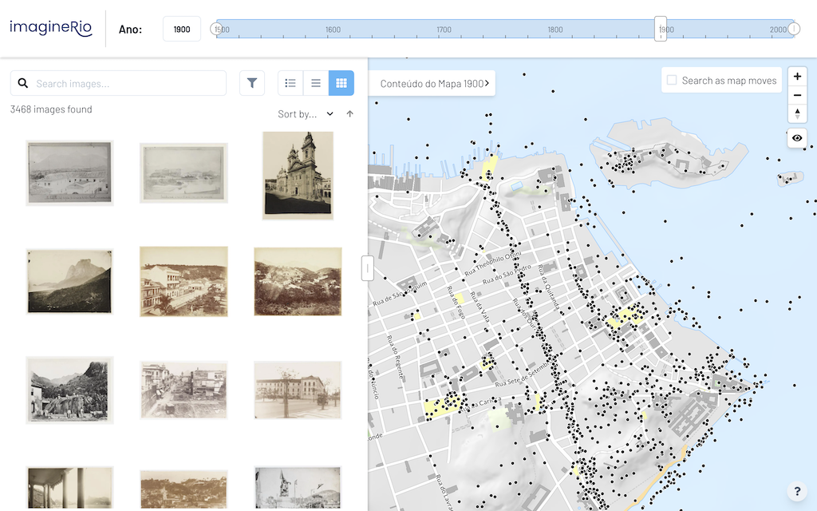

png

Offering a user-friendly interface to browse visual documents through space and time, *imagineRio* presents georeferenced information as a simplified web-based Historical Geographic Information System (HGIS). Streets, parks, public spaces, neighborhoods, and landscapes can be visualized on an interactive basemap, along with georeferenced historical maps and artistic representations of specific regions in the city. The new version also expands the search capabilities of the image library, which now has a dedicated panel on the left side of the screen. Within it, users can search and filter results over the map panel, located on the right side of the screen. This integration opens up new research dimensions for scholars interested in change over time, urban photography, architectural design, urban planning, and environmental history.

START HERMENEUTICS

As with most web-based projects, the history of *imagineRio*’s software development is closely tied to how browsers, web standards, and libraries shape technical possibilities and user interface conventions. During its initial years, the main technical challenge of the project was the styling and rendering of a large geographical dataset using raster tiles, a rendering technology that required basemaps to be processed year-by-year using a custom server. The resulting experience was that, for each year selected in the timeline, the user had to wait for the square tiles to load. In 2021, with the adoption of a new mapping engine that relies on vector tiles as a rendering solution, the graphical computation was transfered from the server to the client. This allowed the geographical data curated by Rice’s Spatial Studies Lab to load instantly to the user.

END HERMENEUTICS

START HERMENEUTICS

To adapt to similar changes in the future, *imagineRio* adopted a microservices architecture, with self-contained applications for data wrangling, search, and front-end client. Among these is a serverless image repository compliant to the IIIF specifications. The image metadata processing was also redesigned, with a Extract-Transform-Load (ETL) pipeline reconciling entities with Wikidata to offer multilanguage labels in English and Portuguese. The project is open source and [published on Github](https://github.com/imaginerio/) under a MIT License.

END HERMENEUTICS

The craft of visual arguments in spatial history is both a practical and theoretical challenge (*Rankin 2020*). As with any map, abstraction and selection shape its production, and maps only work because they simplify the world. Most geographical data from *imagineRio* comes from the georeferencing and vectorization of historical maps, which can be problematic, as some were produced under a colonial mindset in which “cartographic silence becomes an affirmative ideological act” (*Harley 1988*:70). To ensure that the platform does not oversimplify critical aspects of the city’s history, we use these maps to create a digital cartographic representation, organized in different layers that can be revised and improved. The sources we use come from a variety of libraries and archives, such as the Biblioteca Nacional (Brazil), the Arquivo Nacional (Brazil), the Arquivo Geral da Cidade do Rio de Janeiro (Brazil), the Library of Congress (USA), the Arquivo Historico Ultramarino (Portugal), and others. Although the resulting layers (streets, buildings, squares, land use, etc.) were built from many maps, gaps and omissions remain. Neighborhoods outside of the central city are only superficially mapped over time, leaving the history of these areas and residents largely silent. Similarly, *imagineRio* does not include the larger environmental context of the Guanabara Bay, as it falls outside of the city’s limits. These are issues that can be addressed over time, as we develop communities of users interested in contributing to the mapping of the city.

Another issue affecting the project is that its interactive features cannot be successfully integrated into scholarly publications. Traditional academic journals only offer black and white illustrations, which hardly do justice to interactive visualizations (*Frank, Berry 2010*). Born-digital journals offer scholars the opportunity to include color illustrations and zoomable maps, making specialized journals attractive venues (*Metcalf 2014*). Academic platforms like Cambridge Core offer similar digital enhancements, thereby bringing research developed on digital platforms into well-established academic journals (*Metcalf, Smith, Kennedy 2022*). Yet, the end result is a PDF file, which is often hidden behind a subscrition paywall. For instance, the Laboratory of Urban Analysis and Digital Representation at the Federal University of Rio de Janeiro (Laurd/UFRJ) has created several 3D models of *Morro do Castelo* representing its demolition, but they can only be seen in academic publications in 2D (*Andreatta, Vilas Boas 2021*). Similarly, most users of *imagineRio* who wish to include an illustration drawn from their research simply take a screenshot of the interactive map in a certain year (*Loredano 2021*). In exceptional cases, scholars have created argument-driven maps using the layers of *imagineRio* with the help of a GIS specialist. Such maps appears in the doctoral theses of historians Antonio Higino da Silva and Higor Figueira Ferreira (*Silva 2019*, *Ferreira 2020*).

Customized maps do an excellent job of visualizing historical arguments, for they display data drawn from the interests, sources, and research questions of their authors. However, most scholars do not have access to GIS specialists, and even when they do, the final results often lack in terms of the expressive cartography present in *imagineRio*. Static visual representations are useful to give spatial context to historical arguments, but they do not convey to the reader the experience of interacting with layers of geographic and temporal information. Considering these limitations, how could the interactive features of *imagineRio* be better integrated into scholarly publications? How could its users contribute data to the platform in the context of their own research? And how could we promote community engagement around Rio’s spatial history, online and on the ground? To address these questions, we first experimented with map-based storytelling before settling on creating our own tool.

## Storytelling with Maps

Central to the user experience of *imagineRio* is the ability to zoom to a specific area, to select a date, to highlight layers, and to see the map respond accordingly. We became interested in bringing these interactive elements so that our users could write their own narratives, using *imagineRio* as a basemap. To address the limitations of scholarly publications, we began experimenting with ESRI map-based storytelling products, which offered ways to incorporate maps, images, and text in an interactive, online publication. In 2018, we crafted our first bilingual story map about the remains of the *Carioca* aqueduct in Rio (*Metcalf 2018*). After that, through ESRI’s various templates, such as Cascade and Map Journal, we experimented with ways to combine maps, text, and imagery. To test these possibilities, we reached out to two senior scholars of Rio de Janeiro, Mary Karasch and Sandra Lauderdale Graham, and proposed the creation of story maps that would weave together their research and *imagineRio* with the goal of reaching a broader, online audience.

In the past decade, map-based visual storytelling became an important mode of readership engagement, offering hybrid user experiences with significant impact in fields such as data journalism. (*Roth 2021*, *Song, Roth, Houtman, Prestby, Iverson, Gao 2022*). John Branch’s Snow Fall piece, published by *The New York Times* in 2012, was particularly impactful in expanding the range of possibilities for web-based multimedia storytelling (*Branch 2012*). The rise of interactive narratives subsequently led to open-source projects that harnessed their integration with maps, such as the *Odyssey.js* project (*CartoDB 2014*). Often promoted as showcases of mapping companies, most tools rely on a technique known as *scrollytelling*, in which a webpage animates in reaction to the scrolling of the mouse (*Perez 2019*,*Mapbox 2019*,*Morini, Thomet 2020*). In our case, we decided to start exploring ESRI products by relying on an institutional subscription from our university. ESRI’s storytelling solutions have been renamed and relaunched as different products many times, with the most recent being the StoryMaps (*ESRI 2022*).

In the story map *“Rio de Janeiro: A Colonial City until 1850”* by historian Mary Karasch, we selected the Story Map Journal template for an argument intended to unfold chronologically. Because the template features two parallel windows, readers could engage simultaneously with Karasch’s written text, on the left, and with *imagineRio*, on the right. Accompanied by images selected by Karasch, the story map allowed readers to easily accompany the changes in the city over time, and to see them spatially. Readers may enter *imagineRio* through an iframe and freely explore its features, zooming in and out, moving around, and selecting georeferenced maps and geolocated images to view. Returning to Karash’s illustrated text in the left window, readers may enlarge images in order to see greater detail. Karasch’s text resembles an academic article–it has footnotes and endnotes (not supported in the original template), an argument, and it follows the scholarly writing conventions used by historians. This story map, available in both English and Portuguese, resulted in an authoritative text that is interactive, heavily illustrated, and spatially specific (*Karasch 2020*).

from IPython.display import Image, display  
metadata={  
 "jdh":{  
 "module": "object",  
 "object": {  
 "type": "image",  
 "source": [  
 "Karasch's story map has _imagineRio_ embedded as an iframe."  
 ]  
 }  
 }  
}  
display(Image("media/storymap-karasch.png", width=1000), metadata=metadata)

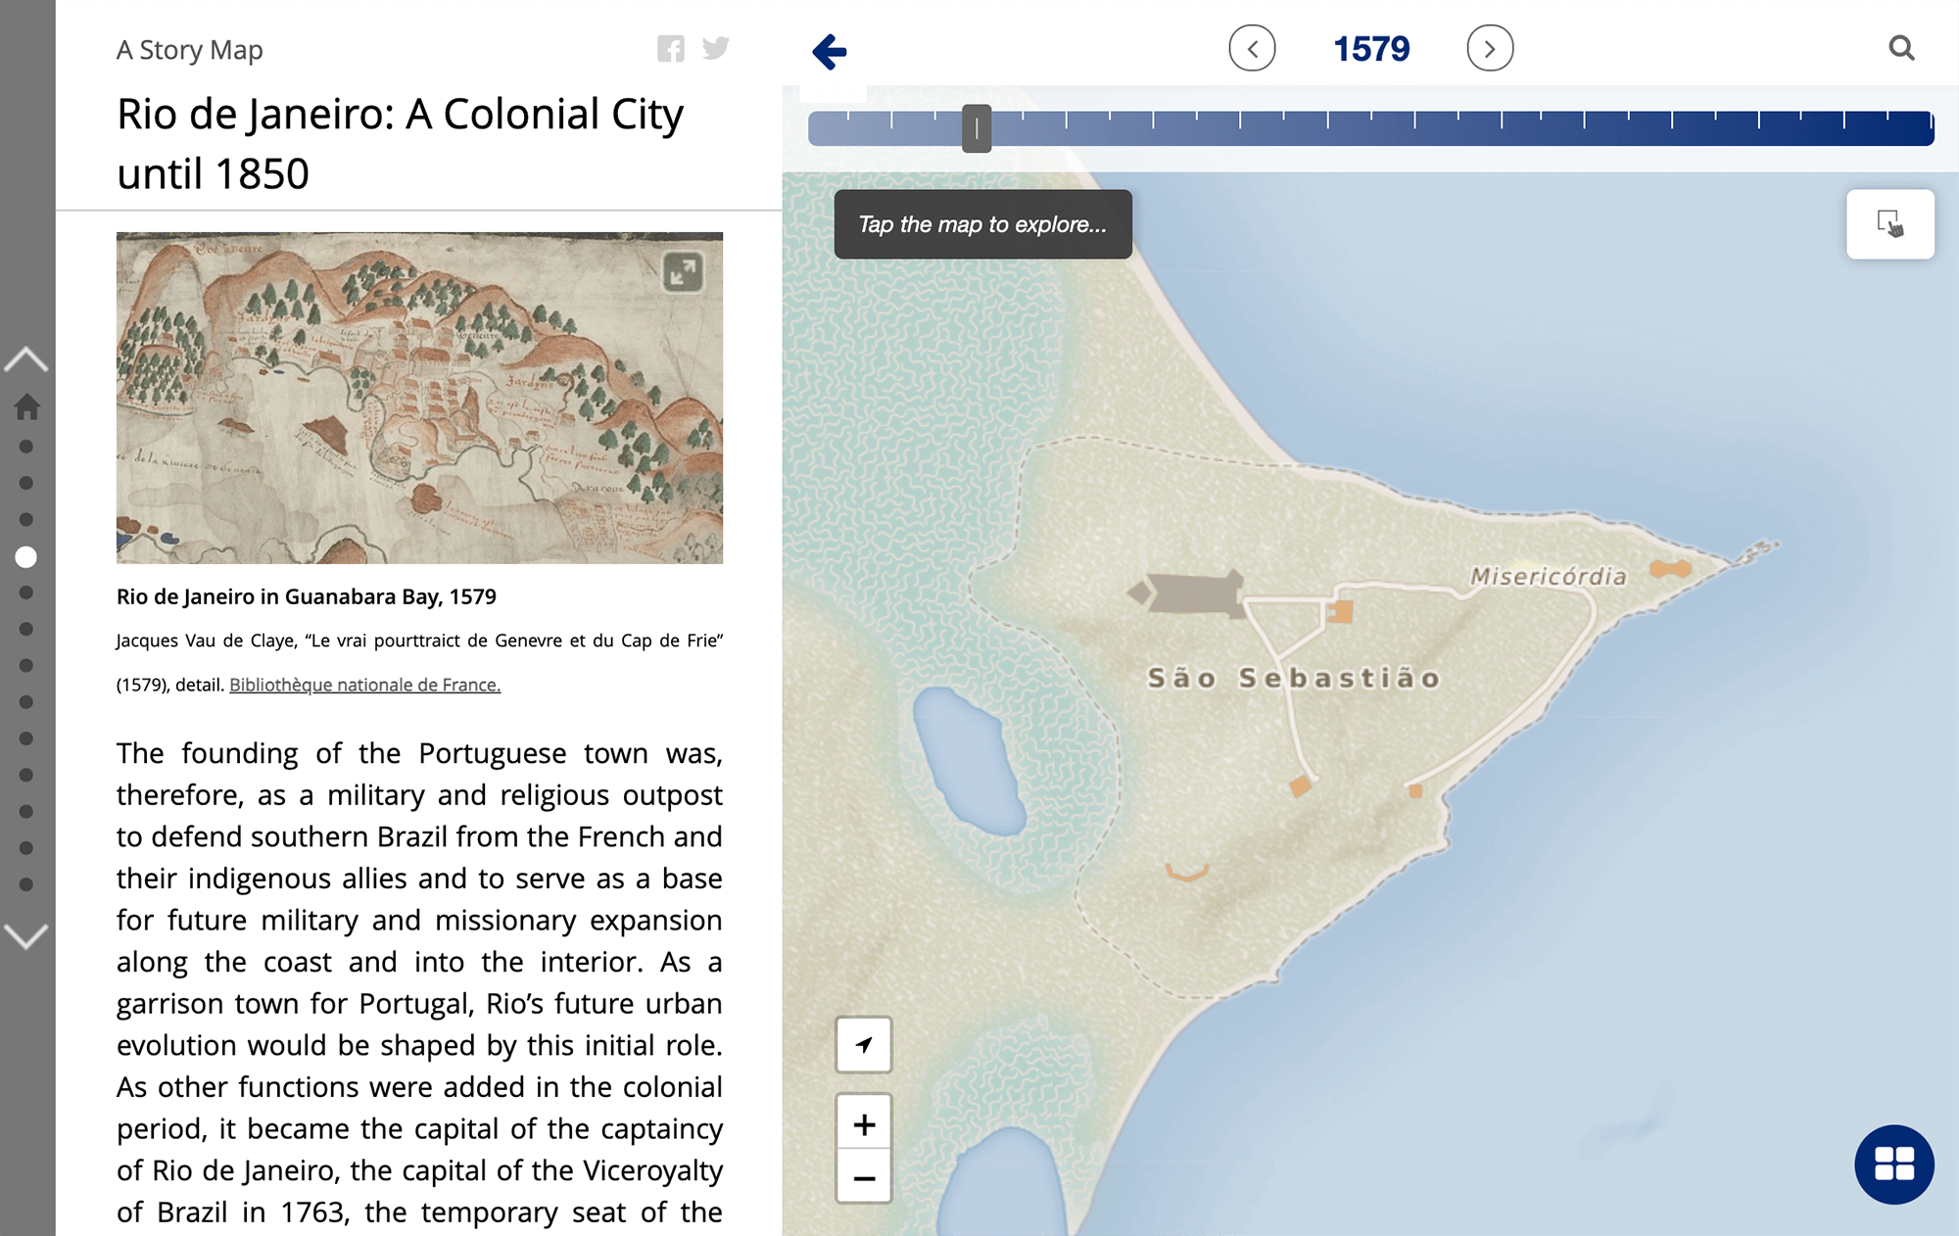

png

In the story map *“Henriqueta’s Day on the Streets, Rio de Janeiro, 1850s”* by historian Sandra Lauderdale Graham, we selected the Story Map Cascade template for a thematic and focused argument on how an African streetseller moved through the city on a typical day. In this story, the text scrolls over images and georeferenced historical maps, which were custom labeled and highlighted to illustrate specific places. These images appear in various sizes, from full screen to small size, with linked citations that take readers to their respective archival collections. At the end of the story, readers are invited to *imagineRio* to explore the city in the 1850s. This story map does not have lengthly academic footnotes or endnotes, but it ends with a detailed narrative on the sources used to reconstruct Henriqueta’s daily movements, including specific archival references. Also bilingual, its Portuguese version was adopted as an assigned reading by several history professors in Rio, after the COVID-19 pandemic shut classrooms (*Graham, Metcalf 2020*).

from IPython.display import Image, display  
metadata={  
 "jdh":{  
 "module": "object",  
 "object": {  
 "type": "image",  
 "source": [  
 "Lauderdale Graham's story map uses custom labels to illustrate its spatial context."  
 ]  
 }  
 }  
}  
display(Image("media/storymap-graham.jpg", width=1000), metadata=metadata)

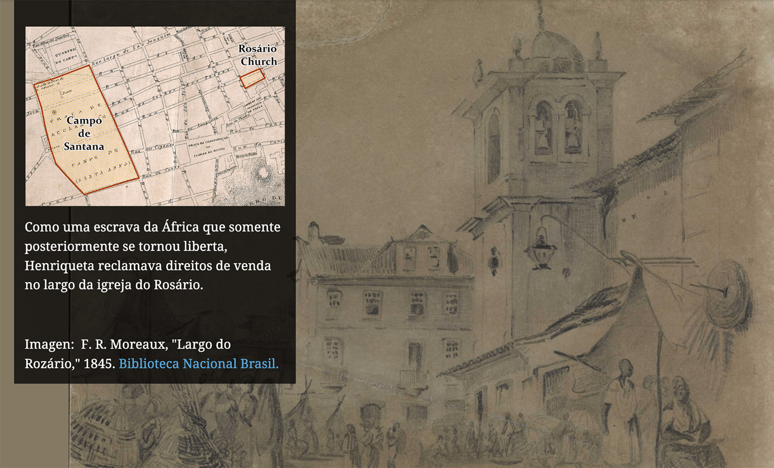

jpeg

Drawing from these previous experiences, in the 2020 spring semester, we decided to use story maps for an assignment in a History of Brazil undergraduate course. Students had to pick a theme from the novel *Memórias de um Sargento de Milícias* (1852) by Manuel Antônio de Almeida, to research their chosen theme in academic publications, and to create a narrative about life in Rio during that moment in time. The original goal was for each student to create an independent story map, whereas in previous years, students had created posters or slide presentations. However, with the outbreak of Covid-19, we decided to ask students to contribute to one, collaborative story map. The instructor was responsible for a substantial part of the writing, and each student contributed an independent section. Each section had a map, created by a GIS specialist, which helped the students to annotate their own information. These annotations were displayed over the *imagineRio* basemap, so that spaces described in the text could be visualized. The resulting story map is titled *“Rio de Janeiro in the Time of the King”* and was also translated into Portuguese (*Metcalf, Donnelly, Humphrey, Gao, Lin 2021*).

from IPython.display import Image, display  
metadata={  
 "jdh":{  
 "module": "object",  
 "object": {  
 "type": "image",  
 "source": [  
 "The story map created with Rice students uses _imagineRio_'s raster tiles."  
 ]  
 }  
 }  
}  
display(Image("media/storymap-students.png", width=1000), metadata=metadata)

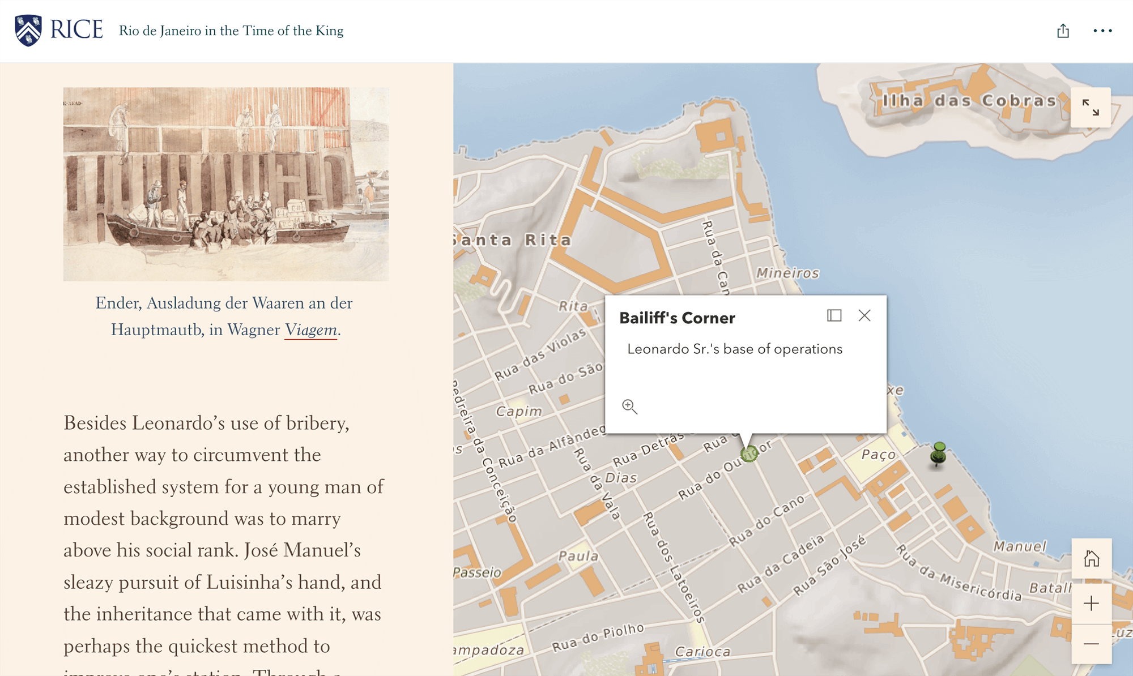

png

Both Karasch and Lauderdale Graham’s story maps are rich interactive publications that bring academic research to broader audiences. Nevertheless, each took months to create. Scholars mostly dedicated to print, these guest authors found working outside of traditional workflows difficult. In Karasch’s case, the author focused on the text and the selection of historical images to illustrate it, while a team created the story map. This team included a GIS specialist, a historian familiar with *imagineRio*, and an editorial assistant. In Graham’s case, the story map evolved into a co-authored project with Metcalf, who created and exported custom maps from ArcGIS. With the students, ESRI products seem ideal for teaching tech-savvy individuals, allowing them to work intensively with historical images and maps. Particularly with students who cannot read Portuguese, the use of visual documents helps them to engage with the assignment in sophisticated ways. Nevertheless, it was clear that a GIS specialist was needed to create the interactive maps. In addition to the instructor, two specialists were involved in the project: one set up accounts and taught the students the platform, while the other created the basemaps from *imagineRio* that each student annotated.

Although ESRI storytelling products have been widely adopted, our experience working with students and scholars to create story maps with *imagineRio* data revealed several limitations. Despite the well-designed editor, the various StoryMaps products required writers to rely on GIS specialists to fully develop the mapping component of their stories. All of the story maps we created required consultation, both for learning the editor and creating the maps. Technically, the integration with *imagineRio*’s geographical data felt either as a workaround (iframe) or of limited interactive functionality (raster tiles). Moreover, ESRI products require a paid subscription. These limitations convinced us that proprietary tools were out of reach for most of our audience, since many of our intended users are in Brazil and are unlikely to have access to institutional or financial support. Therefore, we developed our own open-source solution to address these limitations.

## Building a tool

We conceived *imagineRio Narratives* as a map-based storytelling tool designed for scholars, students, and dedicated amateurs interested in the spatial history of the city of Rio de Janeiro. Our main goal was to create a writing tool for spatial narratives that would be simple to use, bilingual, and without the need for GIS expertise. We wanted to give access to the geographical layers and georeferenced maps of *imagineRio*, which makes it easy for any user to visualize change over time. More than merely encouraging the sharing of research materials, we were inspired by how the production of history could benefit from an open-source attitude towards argument-driven digital history (*Locke, Wright 2022*, *Robertson, Mullen 2021*). Considering that many regions and groups of the city were erased from historical maps and silenced from archival sources, we needed a way for users to elaborate and to annotate their own spatial information. The writing of Rio’s spatial history had to be open to new voices and perspectives, especially from groups not fully represented in its official historical record.

START HERMENEUTICS

Regarding project management, our aim was to develop a storytelling tool that could leverage the full potential of vector tiles and adhere to the best practices in interactive cartography design. The project comprised of three stages. During Stage One (February to August 2020), we conceptualized and developed an initial prototype. During Stage Two (September 2020 to August 2021), we established a user group in Rio de Janeiro to create narratives and provide feedback. Finally, during Stage Three (March 2022 to March 2023), we completed bilingual translations and conducted specialized workshops with teachers in Rio. Funding for these stages was provided by grants from Rice University’s Humanities Research Center, through its Spatial Humanities Initiative, which is supported by the Andrew W. Mellon Foundation, and the Ken Kennedy Institute.

END HERMENEUTICS

START HERMENEUTICS

As for software development, *imagineRio Narratives* is a web application that utilizes KeystoneJS, an open-source Content Management System (CMS) with a MongoDB database. The NextJS framework was used to create the user interface, which accounts for roughly 80% of the total development effort. The front-end interacts with the database via a GraphQL API. To enhance functionality, the application is integrated with *imagineRio*’s microservices architecture that incorporates the diachronic atlas map renderer, the MapboxGL basemap styles, and the imaginerioSearch library to retrieve information on geographical features and basemaps. The application’s data model is structured around projects, which consist of ordered sets of cards. Each card stores customization variables and metadata related to the map orientation. All data is organized hierarchically under user profiles, allowing users to export their personal data as JSON files at any time. The data contained in a sample project reads as follows:

END HERMENEUTICS

#START HERMENEUTICS  
  
{  
 "User": {  
 "name": "Warren Dean",  
 "email": "wdean@nyu.edu",  
 "projects": [  
 {  
 "title": "With Broadax and Firebrand",  
 "description": "The Destruction of the Brazilian Atlantic Forest",  
 "tags": [  
 {  
 "name": "Atlantic Forest"  
 },  
 {  
 "name": "Environmental History"  
 }  
 ],  
 "category": "History",  
 "imageTitle": "Featured Image",  
 "source": "https://www.example.com/",  
 "url": "https://cnd.imaginerio.org/image-1.jpg",  
 "cards": [  
 {  
 "title": "Title of the card",  
 "description": "Description of the card",  
 "order": 1,  
 "size": "Medium",  
 "year": 1818,  
 "longitude": -43.18914483352785,  
 "latitude": -22.896216487308735,  
 "zoom": 16.20517641780579,  
 "bearing": 175.87998354956002,  
 "pitch": 32.482914224253186,  
 "selectedFeature": "null",  
 "layers": [],  
 "basemap": {  
 "ssid": "2589170",  
 "title": "Planta da Cidade do S. Sebasti\u00e3o do Rio de Janeiro",  
 "firstYear": 1817,  
 "lastYear": 1821,  
 "longitude": -43.1810763343022,  
 "latitude": -22.9010009606826,  
 "creator": "Souto, P. S. F."  
 },  
 "opacity": 1,  
 "media": "null",  
 "imageTitle": "Sample Image",  
 "source": "https://www.example.com/",  
 "url": "https://cnd.imaginerio.org/image-1.jpg",  
 "annotations": [  
 {  
 "feature": "{\"type\":\"Feature\",\"properties\":{\"title\":\"Parque do Mendanha\"},\"geometry\":{\"type\":\"Point\",\"coordinates\":[-43.456000046961684,-22.84524094246816]},\"id\":\"62145f786d1ade00567ca229\"}"  
 }  
 ]  
 }  
 ]  
 }  
 ]  
 }  
}  
  
#END HERMENEUTICS

{'User': {'name': 'Warren Dean',  
 'email': 'wdean@nyu.edu',  
 'projects': [{'title': 'With Broadax and Firebrand',  
 'description': 'The Destruction of the Brazilian Atlantic Forest',  
 'tags': [{'name': 'Atlantic Forest'}, {'name': 'Environmental History'}],  
 'category': 'History',  
 'imageTitle': 'Featured Image',  
 'source': 'https://www.example.com/',  
 'url': 'https://cnd.imaginerio.org/image-1.jpg',  
 'cards': [{'title': 'Title of the card',  
 'description': 'Description of the card',  
 'order': 1,  
 'size': 'Medium',  
 'year': 1818,  
 'longitude': -43.18914483352785,  
 'latitude': -22.896216487308735,  
 'zoom': 16.20517641780579,  
 'bearing': 175.87998354956002,  
 'pitch': 32.482914224253186,  
 'selectedFeature': 'null',  
 'layers': [],  
 'basemap': {'ssid': '2589170',  
 'title': 'Planta da Cidade do S. Sebastião do Rio de Janeiro',  
 'firstYear': 1817,  
 'lastYear': 1821,  
 'longitude': -43.1810763343022,  
 'latitude': -22.9010009606826,  
 'creator': 'Souto, P. S. F.'},  
 'opacity': 1,  
 'media': 'null',  
 'imageTitle': 'Sample Image',  
 'source': 'https://www.example.com/',  
 'url': 'https://cnd.imaginerio.org/image-1.jpg',  
 'annotations': [{'feature': '{"type":"Feature","properties":{"title":"Parque do Mendanha"},"geometry":{"type":"Point","coordinates":[-43.456000046961684,-22.84524094246816]},"id":"62145f786d1ade00567ca229"}'}]}]}]}}

### Gallery

The gallery is the entry point, where users can explore the narratives that have been published by other users. There, each published narrative is linked to its own detail page, which presents information such as the author’s name, title, and description. Additionally, the detail page features images that are relevant to the story, helping to provide context and visual aids to the reader. The homepage features a carefully curated selection of narratives, with the most recent publications listed first. These narratives are categorized by themes, such as history, architecture, or literature, and can be further filtered using tags provided by the author. The categories and tags provide a useful means for users to explore narratives that are relevant to their interests, whether they are seeking to learn more about a particular topic or simply looking for an engaging story to read.

from IPython.display import Image, display  
metadata={  
 "jdh":{  
 "module": "object",  
 "object": {  
 "type": "image",  
 "source": [  
 "The gallery of _imagineRio Narratives_."  
 ]  
 }  
 }  
}  
display(Image("media/narratives-gallery.png", width=1000), metadata=metadata)

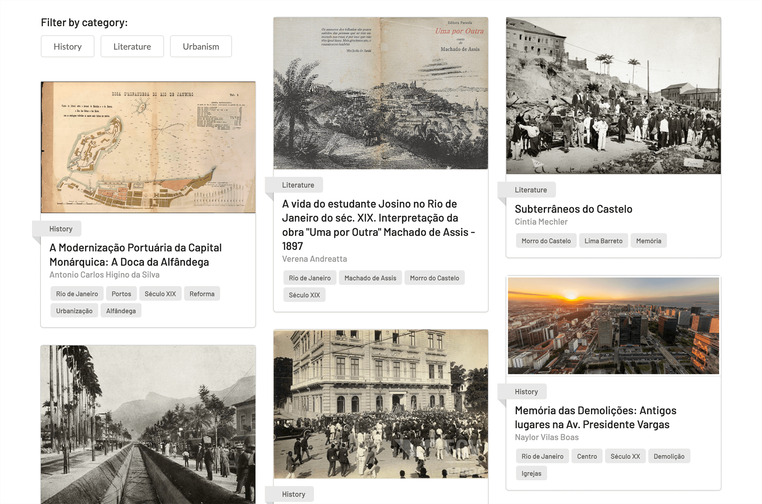

png

START HERMENEUTICS

We are currently exploring different ways to operate the gallery and considering various options that would best serve our users. One option is to have an open gallery that allows anyone to publish their narrative. In this case, we would periodically review the published narratives and showcase those that we find to be particularly interesting or noteworthy, designating them as “Editor’s Picks.” Another potential option is to implement a simplified peer-review process where narratives would be sent to an editorial board for evaluation. If approved, these narratives would receive a stamp of peer-review, which would be useful for academic purposes as *imagineRio Narratives* could serve as a form of scholarly publishing. Lastly, we are considering offering personal galleries linked to user profiles, which would allow authors to publish their work without impacting the main gallery. We recognize that some users may prefer to use our tool for annotating their spatial research rather than writing publishable narratives, and we aim to provide a platform that caters to all types of users.

END HERMENEUTICS

### Viewer

After selecting a narrative, the user will be redirected to the viewer interface. In this interface, the contents of the narrative are structured in a series of cards that are displayed alongside the interactive map. The use of cards encourages users to be brief and to divide long texts into shorter sections, which can include images with captions or audiovisual content. Each card is linked to a specific geographic position and orientation in *imagineRio*. As users scroll through the narrative, the application determines the location of the next card and sends its information to the mapping engine. The mapping engine then animates the transition between the geographic coordinates of the current card and the next one. This approach ensures that the user has a smooth and seamless experience as they navigate through the narrative.

from IPython.display import HTML, display  
metadata={  
 "jdh":{  
 "module": "object",  
 "object": {  
 "type": "video",  
 "source": [  
 "Short video of the narrative viewer."  
 ]  
 }  
 }  
}  
display(HTML('<iframe width="640" height="400" src="https://www.youtube-nocookie.com/embed/8qdSeuBhy8E?controls=0" title="YouTube video player" frameborder="0" allow="accelerometer; autoplay; clipboard-write; encrypted-media; gyroscope; picture-in-picture" allowfullscreen></iframe>'), metadata=metadata)

### Editor

The editor is the authoring environment for users who want to create their own narratives. It allows images to be uploaded onto cards with different dimensions, such as small, medium, or fullscreen. Additionally, image captions and links can also be added directly to the card. Users can also use georeferenced maps from *imagineRio* within the editor, enabling them to easily incorporate historical maps and other geospatial data into their narratives. Although users cannot import georeferenced iconography for now, they can upload their own research images to illustrate their arguments. The editor also supports embedded media from external providers such as YouTube, Vimeo, and Soundcloud. In the map window, users can annotate and label geographic features using points, lines, and polygons, highlighting specific places and events relevant to their arguments. For example, a writer documenting changes in a neighborhood can drop points on the map and add labels that make it clear where the locations described lie. Furthermore, users can manipulate the annotated map by tilting, panning, rotating, or zooming in at any time for a better view.

from IPython.display import Image, display  
metadata={  
 "jdh":{  
 "module": "object",  
 "object": {  
 "type": "image",  
 "source": [  
 "The editor of _imagineRio Narratives_."  
 ]  
 }  
 }  
}  
display(Image("media/narratives-editor.png", width=1000), metadata=metadata)

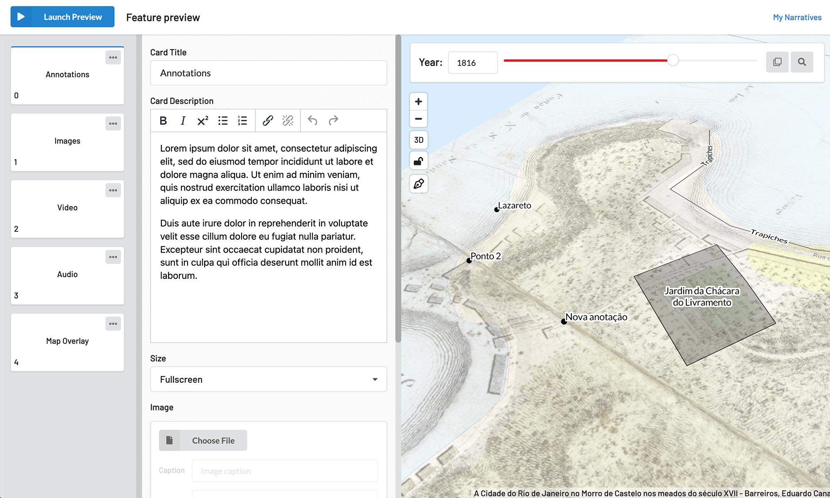

png

START HERMENEUTICS

We took inspiration from popular slideshow applications, such as PowerPoint and Google Slides, as well as writing tools like Scrivener, when designing the editor interface. Our goal was to break down content into small chunks, making it easy for users to organize their thoughts, images, and writing. We decided to use the term “card” instead of “slide” as it was a more fitting frame of reference for users entering into an unfamiliar medium, such as our map-based storytelling tool. To begin creating a narrative, users need to create a project with basic information like a title and description. Once in the editor, the next step is to create a new card, which will be listed on the left sidebar. The middle section of the editor has a simple text editor with formatting options like bold and italics, as well as a superscript font that users can use to manually insert footnotes. Below the text box, there are customization options that allow users to adjust the size of the card or add external media. On the right side of the editor, users will find the map window where they can select the year in the timeline and the geographic position of their interest.

END HERMENEUTICS

## Building a community

The spatial history of any city is doomed to incompletion if not thought as a collective task, which required specific strategies for community engagement. Our approach on that front is to promote user-generated content and to embrace user requests based on real-world use cases. We want to promote a co-design process informed by engaged users, from which we can improve our platform (*Dörk, Müller, Stange, Herseni, Dittrich 2020*). Our first outreach initiative happened between December 2020 and July 2021, when our team hosted a series of online workshops with a group of fifteen researchers, students, and scholars based in Rio de Janeiro. These participants were selected based on their knowledge and lived experiences in the city, as well as their interest in *imagineRio*. Each participant was given their own account and agreed to draft a narrative on a topic of their choice. Our participants included historians, architects, urban planners, social scientists, and educators, and each received a honorarium for their contributions.

The first goal of our user group was to give feedback on the user interface and functionalities of our tool, to test its usability, and to offer suggestions on how to improve it. In order to collect feedback in a structured way, we created an [online forum](https://forum.imaginerio.org/) for users to present themselves, report bugs and request new features. Since we could not honor all requests, we had to select those that seemed most impactful. The forum interaction was key for nurturing a collaborative mindset among participants and for identifying critical issues that needed to be addressed before the public launch. Although active during the group dynamic, forum participation declined after a few months, proving harder to maintain without dedicated community management. We also developed a legal framework to allow user-generated content in *imagineRio*. Lawyers in Brazil and at Rice University crafted a bilingual [Terms of Use](https://www.imaginerio.org/en/terms) and a [Privacy Policy](https://www.imaginerio.org/en/privacy) that added a layer of protection to our users, while giving us ways to remove any instance of hate speech. These documents also guarantee that users could download their personal data and delete their accounts.

Our second goal was to foster community engagement in Rio, empowering users who could serve as ambassadors for our project. This process continued with the public launch of user accounts, which became available for anyone after we concluded the user group meetings. In 2022, together with professor Deborah Fontenelle, who participated in our user group, we started a training program for teachers in Rio. To inspire creative ways to use *imagineRio Narratives* in Portuguese-speaking classrooms, Fontenelle conducted a series of in-person workshops to assess the use of our tool in high schools and undegraduate programs. Finally, to gather this growing community, we hosted the first in-person *imagineRio* seminar at the Instituto Moreira Salles, in November 2022.

## Case Studies

As of May 2024, *imagineRio Narratives* has 140 users, who have created 114 projects, using 268 images, and 1143 annotations. From this pool of projects, we select three case studies to illustrate the diverse range of applications for our tool in exploring aspects of the city’s spatial history. The first case study focuses on a novel. The second case study examines an urban reform. The third case study discusses the history of favelas. Through these examples, we hope to demonstrate how our tool facilitates new ways of understanding the history of Rio de Janeiro, and how a diverse group of users decided to make use of these possibilities.

In “*Agosto de Rubem Fonseca: uma leitura espacial e imagética*” by sociologist Juliana Marques, the narrative takes the reader back to the political crisis that led to the tragic suicide of President Getúlo Vargas in 1954. Marques uses historical photographs, creating a powerful connection between the spaces of the city and the writings of novelist Rubem Fonseca. Adopting two narrative voices: that of Fonseca (in italics) and her own (in light bold), Marques links events with fiction and shows both in the city’s spaces. The reader sees exactly where the key events unfolded in the city, and by using photographs from before and after the event, the reader becomes aware of how the city is changing and remaining the same. A YouTube video imbedded in the Narrative allows the reader to watch a specific clip with the basemap set to the year and location where the events took place (*Marques 2021*).

from IPython.display import Image, display  
metadata={  
 "jdh":{  
 "module": "object",  
 "object": {  
 "type": "image",  
 "source": [  
 "A small-size card with embedded image and annotated coordinates over the 1954 _imagineRio_ basemap. Narrativa by Juliana Marques available at https://narratives.imaginerio.org/view/6033f30a66f6f3001879495f"  
 ]  
 }  
 }  
}  
display(Image("media/case-juliana.jpg", width=1000), metadata=metadata)

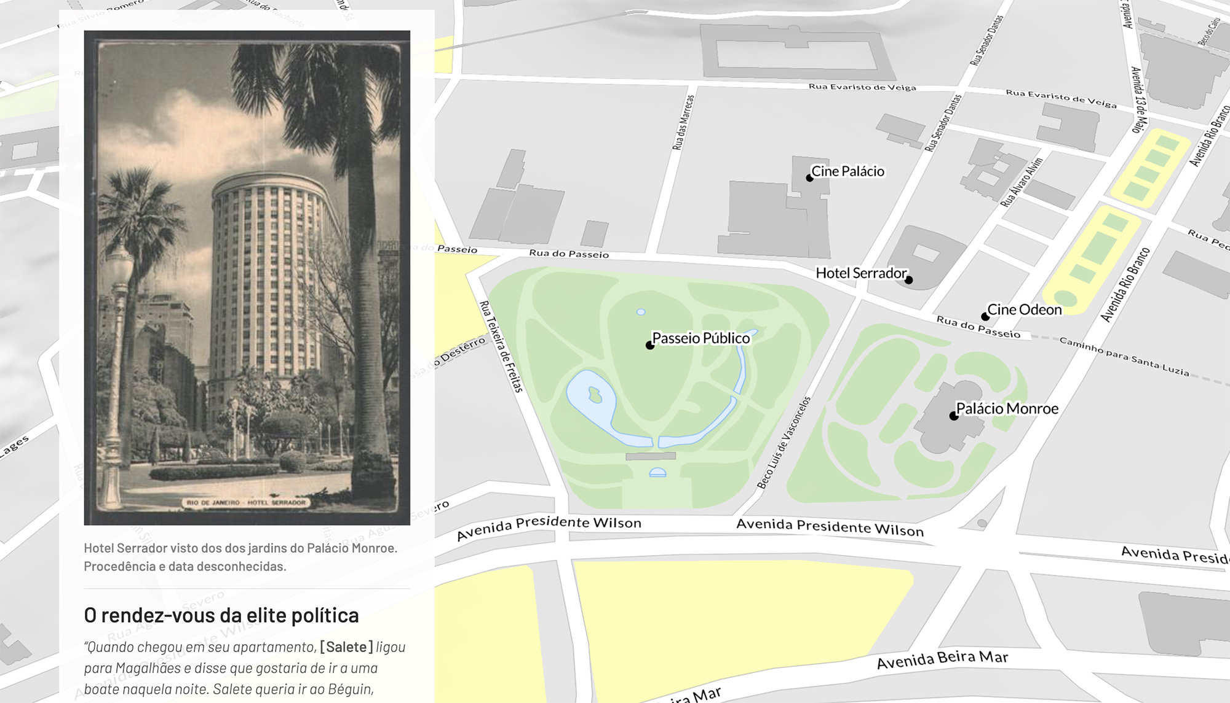

jpeg

In “*A Modernização Portuária da Capital Monárquica: A Doca da Alfândega*” by historian Antônio Carlos Higino da Silva, the narrative places on the basemap are labeled so that readers can clearly follow the argument. Interested in documenting how the port of Rio changed, Silva dropped points on the basemap and added labels. The map is thus customized for the reader: not only is it set for the correct time and for the specific spaces in the city being discussed, but the labels allow the reader to easily and clearly see what the text references. This spatial precision enables the writing of histories that are currently unknown, overlooked, invisible, or not deemed significant (*Silva 2021*).

from IPython.display import Image, display  
metadata={  
 "jdh":{  
 "module": "object",  
 "object": {  
 "type": "image",  
 "source": [  
 "A medium-size card with embedded image and annotated coordinates over the 1885 _imagineRio_ basemap. Narrative by Antonio Carlos Higino da Silva available at https://narratives.imaginerio.org/view/600f1696c405e10018988544"  
 ]  
 }  
 }  
}  
display(Image("media/case-higino.jpg", width=1000), metadata=metadata)

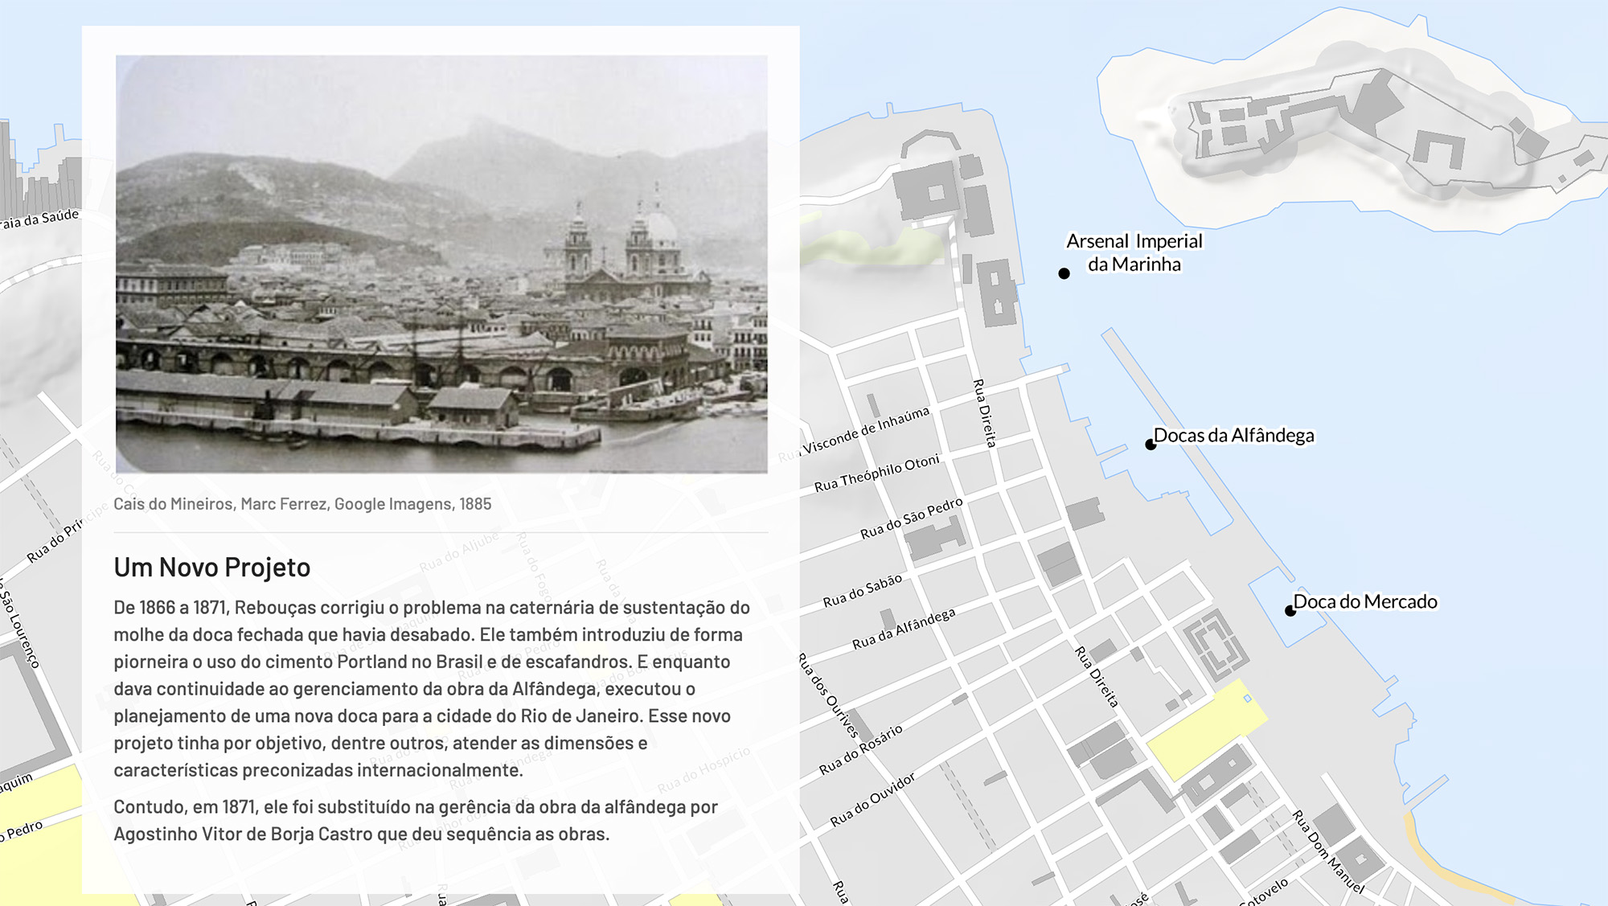

jpeg

In “*Favelas cariocas*” by architect Maria Helena Salomon, the narrative discusses the history of central city slums (*cortiços*) and the later emergence of hillside communities (*favelas*), which are carefully contextualized in time and space. Salomon begins with the specific areas of the city where swamps were filled in the early nineteenth century. By setting the time slider on the basemap to a specific year and by zooming to the desired location, the author shows and the reader sees exactly when and where change is occurring. Moreover, by selecting a georeferenced map, Salomon encourages the reader to engage directly with a cartographic primary source and to visually comprehend how the space was represented at the time of her analysis (*Salomon 2021*).

from IPython.display import Image, display  
metadata={  
 "jdh":{  
 "module": "object",  
 "object": {  
 "type": "image",  
 "source": [  
 "A small-size card with embedded image and annotated coordinates over a georeferenced 1941 map from the Library of Congress. Narrative by Maria Helena Salomon available at https://narratives.imaginerio.org/view/6064c5acf2a23d0018282c15"  
 ]  
 }  
 }  
}  
display(Image("media/case-mariahelena.jpg", width=1000), metadata=metadata)

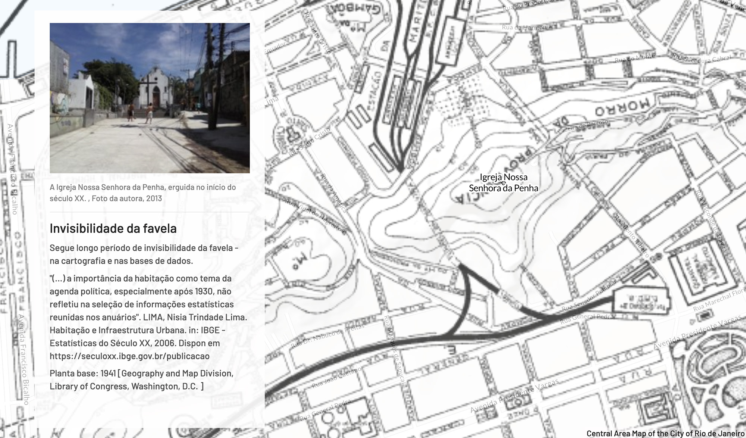

jpeg

## Conclusion

*imaginerio Narratives* marks a turning point in our community outreach, for we recognized the need to empower and engage meaningfully with our users in Rio de Janeiro by offering inclusive ways for sharing their own perspectives. This is particularly critical considering the erasures of historical maps that shape our platform, and the active role that we must have in addressing its shortcomings. Our bilingual storytelling tool allow users to create, label, and annotate any location of the city represented in *imagineRio*, and to embed custom media objects like images, audio and video. In addition, the accompanying online forum offers an open channel for users to share their feedback, and to communicate with and learn from each other. We can now offer many more scholars, students, and dedicated amateurs an writing platform for argument-driven spatial history. We hope that our tool can lead to new ways of interpreting the past, understanding the present, and envisioning a better future for Rio.

## Acknowledgments

The authors are grateful to Bruno Sousa, Livia Tiede, Ludmila de Souza Maia, and Amy Ferguson for their support in the crafting of the story maps discussed in this article. We also thank Farès el-Dahdah and Rice’s Spatial Studies Lab for their tremendous support over the years. We appreciate the support of Rice undergraduate Ethan Denson in drafting the English tutorial, Martim Passos in preparing the video animation, Ivan Borges Sales in developing the terms and policies, and Paula Kupfer for editorial suggestions. A special thanks goes to our user group: Antonio Carlos Higino da Silva, Cintia Mechler, Daryle Williams, Deborah Fontenelle, Higor Figueira Ferreira, José Pessoa, Juliana Marques, Keila Grinberg, Leticia Souza, Lise Sedrez, Maria Helena Salomon, Monica Lima, Naylor Vilas Boas, Sergio Burgi, and Verena Andreatta. Finally, at the Journal of Digital History we would like to thank Frédéric Clavert, Andreas Fickers, Elisabeth Guerard, Mirjam Pfeiffer, the special issue editors Maria Eriksson and Pelle Snickars, and the anonymous reviewers for their generous support.

## Bibliography

Abreu, M. de A.. Geografia Histórica Do Rio De Janeiro (1502-1700). Andrea Jakobsson.

Abreu, M. de A.. “Reconstruindo Uma História Esquecida: Origem E Expansão Inicial Das Favelas Do Rio De Janeiro”. Escritos Sobre Espaço E História, edited by Fania Fridman and Rogério Haesbaert, 1st ed., Garamond.

Abreu, M. de A.. “Sobre a Memória Das Cidades”. Escritos Sobre Espaço E História, edited by Fania Fridman and Rogério Haesbaert, 1st ed., Garamond.

Andreatta, V.and N. Vilas Boas. “Words, Drawings and Digital Representation: Visual Interpretations of the Narratives of Machado De Assis in Morro Do Castelo”. Revista Produção E Desenvolvimento, vol. 7, https://doi.org/10.32358/rpd.2021.v7.543.

Arguing with Digital History working group, .. Digital History and Argument. Roy Rosenzweig Center for History and New Media, https://rrchnm.org/portfolio-item/digital-history-argument-white-paper/.

Aroom, J., et al.. Imaginerio: A Diachronic Atlas of Rio De Janeiro’s Social and Architectural Evolution. https://icaci.org/files/documents/ICC_proceedings/ICC2015/papers/18/145.html. 27th International Cartographic ConferenceRio de Janeiro.

Baics, G., et al.. Mapping Historical New York: A Digital Atlas. Columbia University, https://mappinghny.com/.

Branch, J.. “Snow Fall: The Avalanche at Tunnel Creek”. The New York Times, https://www.nytimes.com/projects/2012/snow-fall/index.html.

Brüggemann, V., et al.. “The Fold: Rethinking Interactivity in Data Visualization”. Digital Humanities Quarterly, vol. 14, no. 3, 2020, http://www.digitalhumanities.org/dhq/vol/14/3/000487/000487.html.

CartoDB, .. Knight Helps Us Advance Map Based Storytelling. https://carto.com/blog/knight-helps-us-advance-map-based-storytelling/.

Delaney, R.. “Backend Visualizations: Tools for Helping the Research Process”. Spatial History Project, http://web.stanford.edu/group/spatialhistory/static/publications/pub11.html.

Dörk, M., et al.. “Co-designing Visualizations for Information Seeking and Knowledge Management”. Open Information Science, vol. 4, no. 1, pp. 217–35, https://doi.org/10.1515/opis-2020-0102.

ESRI, .. “Digital Storytelling with Maps”. Arcgis Storymaps, https://www.storymaps.com/.

Ferla, L.and K. D. Fook, editors. Pauliceia 2.0: Mapeamento Colaborativo Da História De São Paulo (1870-1940). Edited by Luís Ferla and Karla Donato Fook, UNIFESP, https://pauliceia.unifesp.br/.

Ferreira, H. F.. Com Tintas De Liberdade: Professores, Raça E Cartografias Da Educação Na Corte Imperial. Universidade Federal do Rio de Janeiro.

Forssberg, G.. “The Terrain of History (review)”. Digital History Project, http://digitalhistory.unl.edu/p-reviews/terrainforssberg.php.

Frank, Z.and W. Berry. “The Slave Market in Rio De Janeiro Circa 1869: Context, Movement and Social Experience”. Journal of Latin American Geography, vol. 9, no. 3, pp. 85–110, https://doi.org/10.1353/lag.2010.0033.

Frank, Z.. Visualizing Spatial History: The Example of Rio De Janeiro. https://southernspaces.org/2013/visualizing-spatial-history-example-rio-de-janeiro/. Atlanta Studies SymposiumEmory University.

Getty Foundation, .. “Imaginerio Digital Platform Reveals Centuries of Rio De Janeiro’s Urban Evolution”. The Getty, https://www.getty.edu/news/imaginerio-digital-platform-reveals-centuries-of-rio-de-janeiro-urban-evolution/.

Graham, S. L.and A. C. Metcalf. “Henriqueta’s Day on the Streets, Rio De Janeiro, 1850s”. Arcgis Storymaps, https://arcg.is/0zm4jn.

Gregory, I.and P. S. Ell. Historical GIS: Technologies, Methodologies, and Scholarship. 1st ed., Cambridge University Press.

Harley, J. B.. “Silences and Secrecy: The Hidden Agenda of Cartography in Early Modern Europe”. Imago Mundi, vol. 40, no. 1, pp. 57–76, https://doi.org/10.1080/03085698808592639.

Instituto Brasileiro de Geografia e Estatística, .. “Rio De Janeiro - Panorama”. IBGE, https://cidades.ibge.gov.br/brasil/rj/rio-de-janeiro/panorama.

Karasch, M. C.. Slave life in rio de janeiro, 1808-1850. 1st ed., Princeton University Press.

Karasch, M. C.. “Rio De Janeiro: A Colonial City Until 1850”. Arcgis Storymaps, https://ricegis.maps.arcgis.com/apps/MapJournal/index.html?appid=cb6d068b82494db4a2910720494d7c1d.

Kennedy, W.. The New Orleans Mortality Project. Rice University, http://nola.spatialhistory.org/.

Knowles, A. K.and A. Hillier, editors. Placing History: How Maps, Spatial Data, and GIS Are Changing Historical Scholarship. Edited by Anne Kelly Knowles and Amy Hillier, 1st ed., ESRI Press.

Linhares, M. Y.and M. B. Lévy. “Aspectos Da História Demográfica E Social Do Rio De Janeiro (1808-1889)”. L’histoire Quantitative De Brésil De 1800 a 1930, Éditions du Centre National de la Recherche Scientifique.

Locke, J. L.and B. Wright. “History Can Be Open Source: Democratic Dreams and the Rise of Digital History”. The American Historical Review, vol. 126, no. 4, pp. 1485–511, https://doi.org/10.1093/ahr/rhab534.

Loredano, C.. “Série “avenidas E Ruas Do Brasil” VIII – A Rua Da Carioca”. Brasiliana Fotográfica, https://brasilianafotografica.bn.gov.br/?p=21888.

Mapbox, .. Interactive Storytelling. https://www.mapbox.com/solutions/interactive-storytelling.

Marques, J.. “Agosto De Rubem Fonseca: Uma Leitura Espacial E Imagética”. Imaginerio Narratives, https://narratives.imaginerio.org/view/6033f30a66f6f3001879495f.

Metcalf, A. C., et al.. “‘A Mere Gutter!’ the Carioca Aqueduct and Water Delivery in Mid-nineteenth-century Rio De Janeiro”. Urban History, vol. 49, no. 1, pp. 61–87, https://doi.org/10.1017/S096392682000084X.

Metcalf, A. C., et al.. “Rio De Janeiro in the Time of the King”. Arcgis Storymaps, https://arcg.is/KLHmH.

Metcalf, A. C.. Seeking the Carioca Aqueduct. https://ricegis.maps.arcgis.com/apps/Cascade/index.html?appid=742ebbb3acbc4f9cb77b3aa69df517bd.

Metcalf, A. C.. “Water and Social Space: Using Georeferenced Maps and Geocoded Images to Enrich the History of Rio De Janeiro’s Fountains”. E-perimetron, vol. 9, no. 6, pp. 129–45, http://www.e-perimetron.org/Vol_9_3/Metcalf.pdf.

Morini, F.and F. Thomet. “Scrollytelling for Beginners”. Medium, https://medium.com/@scrollyforbeginners/scrollytelling-for-beginners-1-551c5bad9631.

Perez, S.. “Anyone Can Now Create Maps and Stories on Google Earth”. Techcrunch, https://techcrunch.com/2019/11/20/anyone-can-now-create-maps-and-stories-on-google-earth/.

Rankin, W.. “How the Visual Is Spatial: Contemporary Spatial History, Neo‐marxism, and the Ghost of Braudel”. History and Theory, vol. 59, no. 3, pp. 311–42, https://doi.org/10.1111/hith.12162.

Robertson, S.and L. Mullen. “Arguing with Digital History: Patterns of Historical Interpretation”. Journal of Social History, vol. 54, no. 4, pp. 1005–22, https://doi.org/10.1093/jsh/shab015.

Roth, R. E.. “Cartographic Design as Visual Storytelling: Synthesis and Review of Map-based Narratives, Genres, and Tropes”. The Cartographic Journal, vol. 58, no. 1, pp. 83–114, https://doi.org/10.1080/00087041.2019.1633103.

Rumsey, D.and M. Williams. “Historical Maps in GIS”. Past Time, Past Place: GIS for History, edited by Anne Kelly Knowles, 1st ed., ESRI Press.

Salomon, M. H.. “Favelas Cariocas - Parte 1”. Imaginerio Narratives, https://narratives.imaginerio.org/view/6064c5acf2a23d0018282c15.

Silva, A. C. H. da .. “A Modernização Portuária Da Capital Monárquica: A Doca Da Alfândega”. Imaginerio Narratives, https://narratives.imaginerio.org/details/600f1696c405e10018988544.

Silva, A. C. H. da .. Portos De Comércio: Tecnologia, Associacionismo E Redes De Sociabilidade: Os Desafios E as Propostas Modernizadoras De André Pinto Rebouças Para O Brasil Do Segundo Reinado (1850-1890). Universidade Federal do Rio de Janeiro.

Song, Z., et al.. “Visual Storytelling with Maps: An Empirical Study on Story Map Themes and Narrative Elements, Visual Storytelling Genres and Tropes, and Individual Audience Differences”. Cartographic Perspectives, https://doi.org/10.14714/CP100.1759.

Steiner, E.. “Intelligent Cities: Case Study”. The Spatial History Project, http://web.stanford.edu/group/spatialhistory/static/publications/pub103.html.

“Trans-atlantic Slave Trade - Rio De Janeiro Estimates”. “Trans-atlantic Slave Trade - Rio De Janeiro Estimates”. Slave Voyages, https://www.slavevoyages.org/assessment/estimates.

Valladares, L. do P.. The Invention of the Favela. Translated by Robert Nelson Anderson, 1st ed., The University of North Carolina Press.

White, R.. “What Is Spatial History?”. Spatial History Lab - Stanford University.

Williams, D., et al., editors. The Rio De Janeiro Reader: History, Culture, Politics. Edited by Daryle Williams et al., 1st ed., Duke University Press.